**Karan Arora** **R.L. Institute M: 9416974837**

**Max Time : 1 ½ hr** **Class : 12th Chemistry Max Marks : 40**

**Solution + Electrochemistry + Co-ordination + SN1 and S2N reactions**

**+ Preparations of Alcohols , Aldehyde and Alkyl halides**

1. Multiple choice Questions: [ 1 x 10 = 10 ]
2. Among the following which one is paramagnetic and has tetrahedral geometry?

|  |  |  |  |
| --- | --- | --- | --- |
| a) [Ni (CN)4] 2 – | b) [Ni Cl2] 2 – | c) [Ni (CO)4] | d) [Co Cl2 (en)2]+ |

1. Which of the following ions are colourless? Ti3+ , Sc3+ , Ag+ , Cd2+ , Cu2+.

|  |  |  |  |
| --- | --- | --- | --- |
| a) Ti3+ , Cu2+ | b) Sc3+ , Ag+ , Cd2+ | c) Ti3+ , Ag+, Cu2+ | d) Ti3+ , Cd2+ |

1. A 0.002 m aqueous solution of an ionic compound [Co (NH3)5 (NO2)] Cl freezes at – 0.00732 oC. Number of moles of ions which 1 mol of ionic compound produces on being dissolved in water will be. (Kf = 1.86 oC/m).

|  |  |  |  |
| --- | --- | --- | --- |
| a) 3 | b) 4 | c) 1 | d) 2 |

1. The alkyl halide is converted into an alcohol by:

|  |  |
| --- | --- |
| a) elimination | b) dehydrohalogenation |
| c) addition | d) substitution |

1. How much volume of 10 M HCl should be diluted with water to prepare 2 L of 5 M HCl?

|  |  |  |  |
| --- | --- | --- | --- |
| a) 2 L | b) 1 L | c) 3.5 L | d) 4 L |

1. In the reaction, R – OH + HX RX + H2O. Correct order of reactivity of HX towards above reaction is :

|  |  |
| --- | --- |
| a) HCl > HBr > HI > HF | b) HBr > HCl > HI > HF |
| c) HI > HCl > HBr > HF | d) HI > HBr > HCl > HF |

1. Predict major product of the reaction

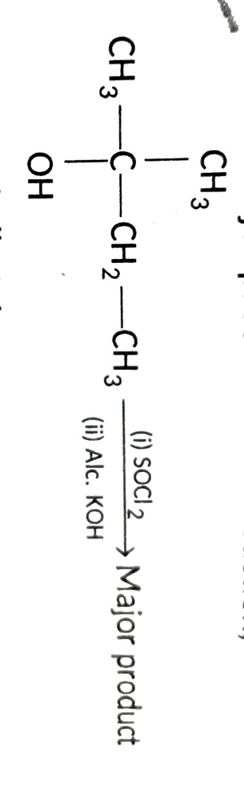

|  |  |  |  |
| --- | --- | --- | --- |
| a) 2-methylbut-1-ene | b) 2-methylbut-2-ene | c) pent-1-ene | d) pent-2-ene |

1. The resistance of 0.01 N solution of an electrolyte is 210 Ω at 298 K with a cell constant of 0.88 cm⁻¹. Calculate conductivity and equivalent conductivity, respectively.

|  |  |
| --- | --- |
| a) 3.95 × 10⁻³ Ω⁻¹ cm⁻¹ , 419.05 S cm² eq⁻¹ | b) 4.19 × 10⁻³ Ω⁻¹ cm⁻¹ , 419.05 S cm² eq⁻¹ |
| c) 6.28 × 10⁻³ Ω⁻¹ cm⁻¹ , 419.05 S cm² eq⁻¹ | d) 5.19 × 10⁻⁴ Ω⁻¹ cm⁻¹ , 519.5 S cm² eq⁻¹ |

1. The value of spin-only magnetic moment for one of the following configurations is 2.84 BM. The correct one is:

|  |  |
| --- | --- |
| a) d² (in strong field ligand) | b) d² (in weak field ligand) |
| c) d³ (in weak as well as strong field ligand) | d) d⁵ (in strong field ligand) |

1. The hybridization of the complex [CrCl2 (NO2)2 (NH3)2] – is :

|  |  |  |  |
| --- | --- | --- | --- |
| a) sp3d2 | b) d2sp3 | c) sp3d | d) cannot be predicted |

**Section – B [ 2 X 6 = 12 ]**

1. A solution of glucose in water is labelled as 20% (w/w). The density of the solution is 1.2 g/mL. Calculate:

(a) molality (b) molarity.

1. Name the following co-ordination compounds and draw their structures:

(a) [CoCl₂(en)₂]Cl (b) [Pt(NH₃)₂Cl(NO₂)]

1. (a) What is a ligand? Give an example of a bidentate ligand.

(b) Explain as to how the two complexes of nickel and have different structures but do not differ in their magnetic behavior.

1. How will you convert: (a) Ethanol to Propan-1-ol? (b) Alkyl halides test paper:
2. Give 4 differences between positive and negative deviation from Raoult's law
3. (i) Which alkyl halide from the following pair is chiral and undergoes faster SN2 reaction?

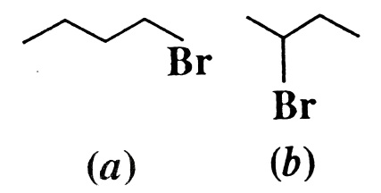

(ii) Out of SN1 and SN2 , which reaction occurs with Inversion of Configuration

**Section – C [ 3 X 6 = 18 ]**

1. (a) C-Cl bond length in chlorobenzene is shorter than C-Cl bond length in CH₃Cl.

(b) Sₙ1 reactions are accompanied by racemisation in optically active alkyl halides.

1. (a) Give reason: Conductivity of CH₃COOH decreases on dilution.

(b) Calculate e.m.f. and ΔG for the cell: Mg(s) | Mg²⁺ (0.001 M) || Cu²⁺ (0.001 M) | Cu(s)

E°(Mg²⁺/Mg) = -2.37 V ; E°(Cu²⁺/Cu) = 0.34 V

1. (a) Calculate the degree of dissociation of 0.0024 M acetic acid if conductivity of this solution is 8.0 × 10⁻⁵ S cm⁻¹. Given: (S cm2 mol – 1 ) : H+ = 349.6 , HCOO –  = 40.9

(b) Conductivity of 0.00241 M acetic acid is 7.896 × 10⁻⁵ S cm⁻¹. Calculate its molar conductivity. If λ° for acetic acid is 390.5 S cm² mol⁻¹, what is its dissociation constant?

1. (a) Identify A and B in the following sequence?

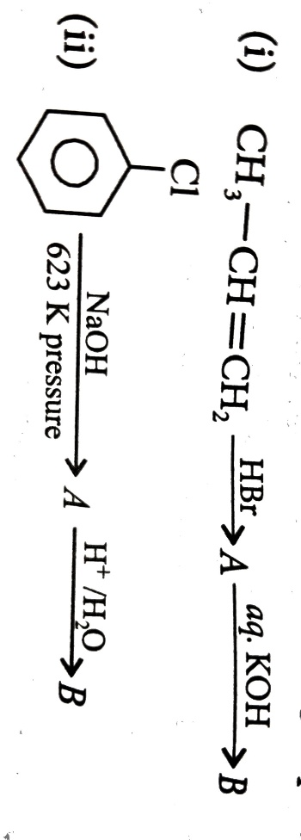

(b) write the product of the following: Chlorobenzene $\underset{→}{ Conc. H_{2}{SO}_{4} , ∆ }$

1. (a) An aqueous solution freezes at 272.4 K, while pure water freezes at 273.0 K. Given: Kₓ = 1.86 K kg mol⁻¹, Kb = 0.512 K kg mol⁻¹ , Vapor pressure of water at 298 K = 23.756 mm Hg.

Determine: (i) The molality of solution (ii) The boiling point of the solution

(iii) The lowering of vapor pressure of water at 298 K.

1. (a) The cell in which the following reaction occurs : 2 Fe3+ (aq) + 2 I – (aq) 2 Fe2+ (aq) + I2 (s), has Eocell = 0.236 V at 298 K. Calculate the equilibrium constant of the cell reaction.

(b) $Λ_{m}^{O}$ for NaCl , HCl and NaAc are 126.4 , 425.9 and 91.0 S cm2 mol – 1 , respectively. Calculate $Λ^{o}$ for Hac.